1. Importance and functions of carbohydrates in body
2. Classification of carbohydrates
3. Learn the given formulas, writing:

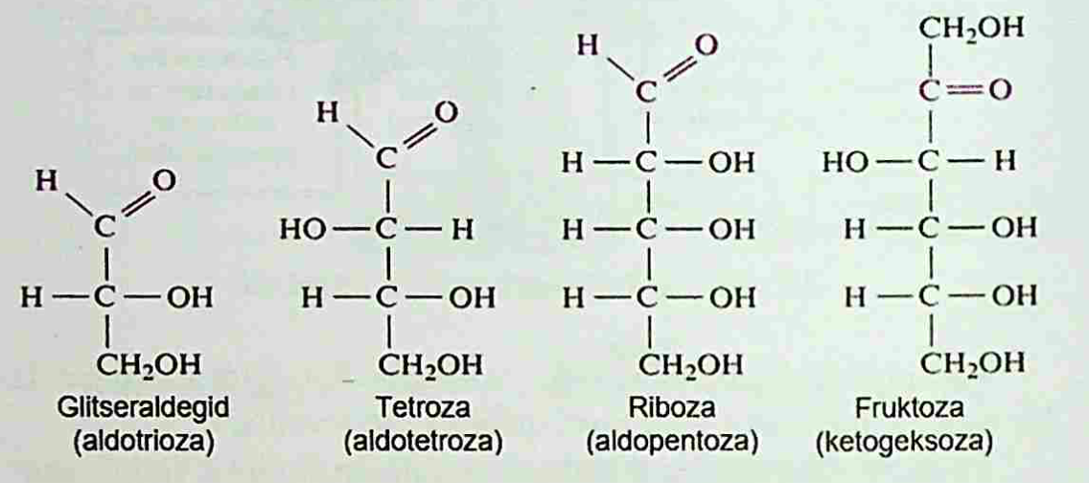

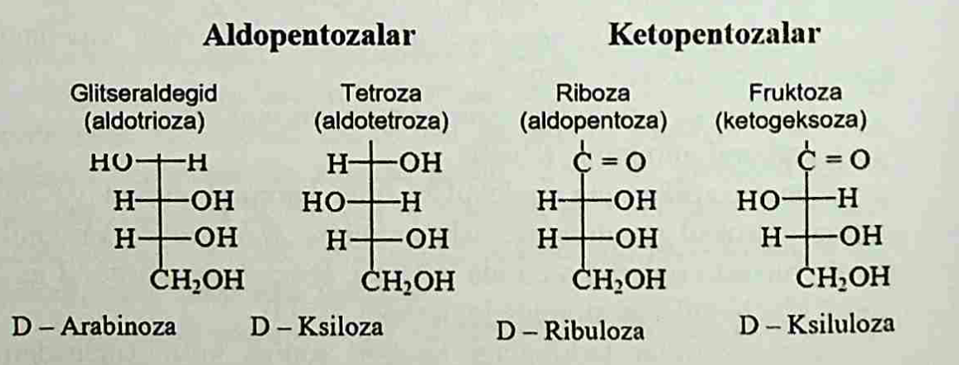

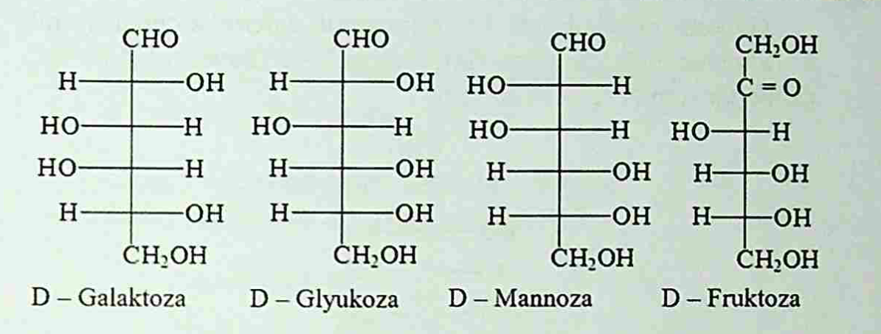

1. Learn spatial isomerism of monosaccharides:

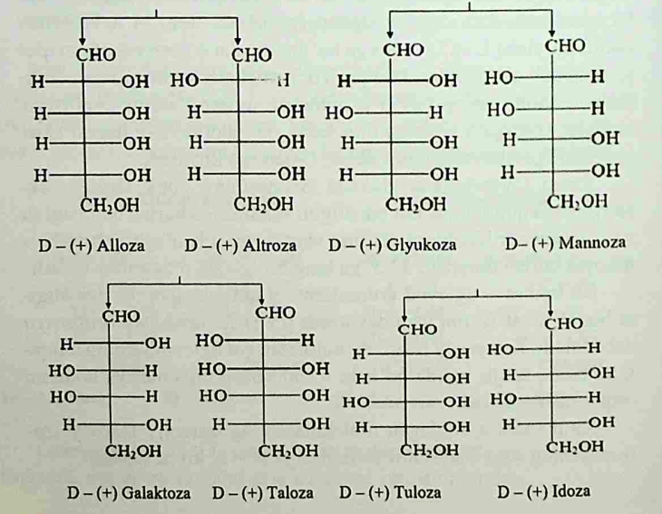

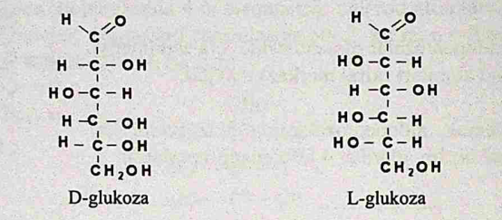

1. Learn The phenomenon of tautomerism

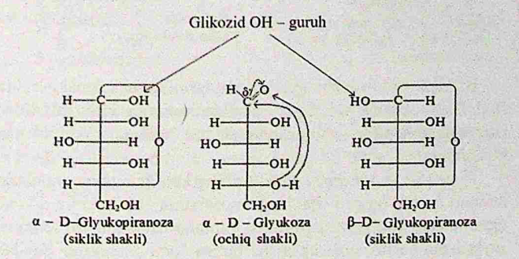

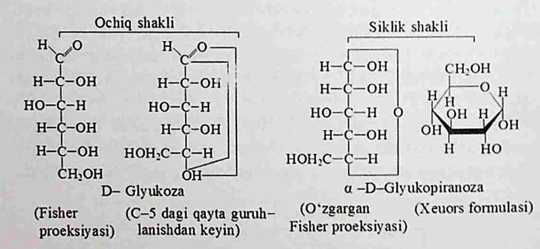

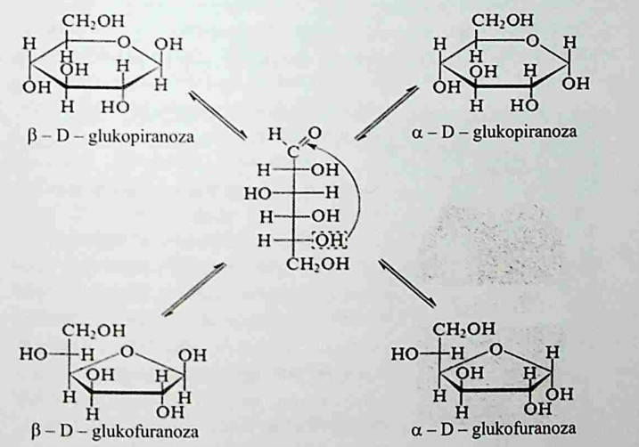

1. Learn about hyperglycemia and hypoglycemia
2. hydrolysis and dehydrogenation reactions
3. Lactose intolerance
4. Polysaccharides , classification, function, reactions, importane